Lost and Found Web App for School/College

**1. Project Overview Statement**

1.1 Project Brief:

**Project Title:** Lost and Found Web Application for Schools and Colleges **Project Duration:** 3 months (Start Date: 22 April 2025 – End Date: 22 July 2025)

**Background:**

In schools and colleges, students and staff often lose items like bags, books, keys, phones, ID cards, or stationery. Most institutions handle these manually through notice boards or reception desks, which is inefficient and often leads to items never being found. In the digital age, a centralized, easy-to-use online platform is necessary for managing lost and found items efficiently.

**Purpose:**

The aim of this project is to design and implement a **Lost and Found Web**

**App** where students and staff can report lost items and view found items. The system will act as a digital bridge to reunite lost items with their rightful owners.

**Scope:**

The application will include:

* A user-friendly interface for students/staff to log in
* Forms to report lost or found items
* A searchable item listing system
* Admin dashboard to review, validate, and manage entries
* Notification system (email or pop-up) to alert users of matched items
* Mobile responsiveness for access on smartphones

**Objectives:**

* Develop a fully functional prototype of the lost and found web app.
* Ensure ease of use for both students and staff.
* Maintain proper records of all reported items.
* Improve the chances of recovering lost items by at least 50%.
* Minimize manual overhead for campus staff. **Key Deliverables:**
* Software requirements document
* System architecture and wireframes
* Front-end and back-end web app prototype
* Test report and user feedback
* Final project report

**1.2 Project Initiation**

**Stakeholders:**

* **Primary Users:** Students and faculty members
* **Secondary Users:** School/College administrators
* **Project Team:** 10-member development group (this coursework group)
* **Sponsor:** University IT Department
* **Mentor:** Course Coordinator (Ashraf Mahmud)

**Estimated Cost:**

Since this is a prototype for coursework, real monetary costs are minimal.

However, if this were implemented in real life, budget items might include:

* Web hosting: £100
* Developer hours: £3000
* Testing and support: £500 **Total Estimate:** ~£3600

**Estimated Time:**

* Requirements & Planning: 2 weeks
* Design & Architecture: 2 weeks
* Development: 4 weeks
* Testing: 2 weeks
* Documentation and Delivery: 2 weeks **Assumptions:**
* All users will have internet access.
* The project will be tested only in the university environment.
* The development team is already trained in basic web technologies.
* Project scope will not change once finalized.

**Constraints:**

* Deadline is fixed (as per coursework: April 18 for submission).
* All tasks must be managed among 10 group members.
* Limited access to external testers (due to university project nature).

**Risks:**

* Team member absence or lack of contribution
* Limited time for testing
* Technology issues (e.g., bugs, hosting problems) • Miscommunication within team

**Project Approach:**

We will follow the **Waterfall Model** for this project:

* Requirements
* Design
* Implementation
* Testing
* Maintenance (Documentation/Wrap-Up)

Criterion 2 – Work Breakdown

Structure (WBS)

**2.1 WBS (Indented List Format):**

* **Level 1: Lost and Found Web Application Project:**

1.1 Project Planning

1.1.1 Define project goals and objectives (8 hours)

1.1.2 Assign team roles and responsibilities (6 hours)

1.1.3 Schedule meetings and set milestones (4 hours)

* **1.2 Requirements Gathering:**

1.2.1 Collect functional requirements (6 hours)

1.2.2 Collect non-functional requirements (5 hours)

1.2.3 Approve final requirements (3 hours)

* **1.3 Design Phase**

1.3.1 Create wireframes and mockups (8 hours)

1.3.2 Define database schema (6 hours)

1.3.3 Review and finalize design (4 hours)

* **1.4 Development Phase**

1.4.1 Frontend development (HTML/CSS/JS) (15 hours)

1.4.2 Backend development (PHP/Python + DB) (20 hours) - 1.4.3 User login and item management module (10 hours)

1.4.4 Admin panel and notifications (8 hours)

**1.5 Testing Phase:**

1.5.1 Create test cases (5 hours)

1.5.2 Conduct user testing (6 hours)

1.5.3 Fix bugs and issues (6 hours)

**1.6 Deployment & Wrap-up:**

1.6.1 Final deployment to demo server (4 hours)

1.6.2 User manual and documentation (6 hours)

1.6.3 Final presentation and submission (3 hours)

**2.2 WBS Dictionary (Summary Table)**

|  |  |  |  |
| --- | --- | --- | --- |
| **Task ID** | **Task Name** | **Description** | **Effort Estimate** |
| 1.1.1 | Define project goals | Identify key outcomes and success metrics | 8 hrs |
| 1.1.2 | Assign roles | Distribute  responsibilities  among members | 6 hrs |
| 1.2.1 | Functional requirements | Document system functionalities | 6 hrs |
| 1.3.1 | Wireframes & Mockups | Visual layout of web app | 8 hrs |
| 1.4.2 | Backend development | Server-side code, database integration | 20 hrs |
| 1.5.2 | User Testing | Students simulate app use and give feedback | 6 hrs |
| 1.6.2 | Documentation | Include Screenshots | 6 hrs |

2.3 Task Deliverables Summary

|  |  |
| --- | --- |
| **WBS (Section)** | **Deliverables** |
| 1.1 Planning | Kick-off plan, team chart, project charter |
| 1.2 Requirements | Requirements document (functional + non-functional) |
| 1.3 Design | Wireframes, architecture diagrams |
| 1.4 Development | Web app source code (frontend + backend) |
| 1.5 Testing | Test case sheet, bug tracker |
| 1.6 Deployment | Link to deployed app, user guide, final report |

Criterion 3: Risk Register

The following risk register identifies the main project risks along with likelihood,

impact, priority, and planned responses. It

covers both technical and team-related risks that could affect successful delivery.

3.1 Risk Register Table

3.2 Explanation of Fields

* **Likelihood (1-5):** How likely the risk is to occur (1=Very Low, 5=Very High)
* **Impact (1-5):** How much the risk would affect the project (1=Minimal, 5=Severe)
* **Priority:** Risk score calculated as Likelihood × Impact
* **Containment Plan:** Action to reduce the chance of the risk occurring
* **Contingency Plan:** Backup plan in case the risk happens

**3.3 Summary of Top Risks**

* **Highest Priority Risk:** Misunderstood requirements (R2). If not identified early, the entire project direction could be flawed.
* **Technical Risk:** Database failure (R1) during backend development may halt progress.
* **Human Factor Risk:** Low participation in testing (R3) could lead to weak feedback and poor app quality.

Criteria 4:Network Analysis

4. Network Analysis

This section includes:

* Gantt Chart Overview
* Network Diagram Description
* Task Relationships
* Resources and Milestones
* **ProjectLibre Guide** (Beginner-friendly)

**4.1 Gantt Chart Overview**

* A **Gantt chart** is a visual timeline of tasks. Each task is displayed with:
* Start and End Dates
* Task Duration
* Dependencies (which task comes after which)
* Assigned resources (team members)
* Milestones
* Here's a simplified list of major tasks and durations used in our project (based on WBS):

|  |  |  |  |
| --- | --- | --- | --- |
| **Task** | **Duration** | **Start date** | **End date** |
| Project Planning | 22 days | 1 feb | 6 feb |
| Requirements Gathering | 5 days | 27 feb | 1 March |
| Design Phase | 5 days | 2 March | 6 March |
| Development  (Frontend +  Backend) | 14 days | 7 March | 20 March |
| Testing Phase | 7 days | 21 March | 28 March |
| Deployment & Wrap-up | 5 days | 29 March | 2 April |

**Milestones:**

* Start Project
* Requirements Approved
* Development Complete
* Final Testing Done
* Final Submission

4.2 Network Diagram Description

Start

↓

Planning → Requirements → Design

↓

Development → Testing

↓

Deployment → End

Criteria 5: Monitoring Plan

**5.1 Introduction**

• Monitoring and controlling are crucial phases in project management that ensure the project progresses as planned and deviations are addressed in a timely manner. In the Lost and Found Web App project, a systematic monitoring plan was developed to track the performance of tasks, evaluate resource efficiency, and manage risks. This section outlines the methods used to monitor progress, apply Earned Value (EV) analysis, record team discussions, and maintain an issue log.

**5.2 Progress Tracking**

* The project team used **ProjectLibre** to create a Gantt chart and task list. Each task was assigned a specific duration, start and end date, and resource. To monitor progress, the team updated the status of tasks weekly by checking the following:
* **% Completion** of each task

• **Actual vs. Planned Dates** • **Milestone Achievements**

* Progress meetings were held every **Friday at 6 PM**, where members discussed what had been completed, any delays, and what was planned for the following week.
* Additionally, the **Gantt chart** was updated weekly to reflect actual progress, allowing visual tracking of slippages or early completions.

**5.3 Earned Value (EV) Analysis**

* Earned Value Analysis (EVA) was implemented to compare project performance against the baseline. This involved three key metrics:
* **Planned Value (PV)**: The estimated value of work planned to be completed.
* **Earned Value (EV)**: The value of actual work completed.
* **Actual Cost (AC)**: The cost incurred for the completed work.
* From these, the following formulas were used:
* **Schedule Variance (SV)** = EV − PV
* **Cost Variance (CV)** = EV − AC
* **Schedule Performance Index (SPI)** = EV ÷ PV
* **Cost Performance Index (CPI)** = EV ÷ AC
* Example Analysis (Mid-Project):

|  |  |
| --- | --- |
| **Metric** | **Value** |
| PV | $1000 |
| EV | $900 |
| AC | $1100 |

**SV = -£100** → Behind schedule

**CV = -£200** → Over budget

**SPI = 0.9** → 90% on schedule

**CPI = 0.82** → 82% cost efficiency

These figures helped the team identify delays in development and allocate more resources to testing earlier than planned.

5.4 Meeting Notes

* To ensure effective communication and follow-ups, meeting notes were recorded for each session. Below is a sample summary:
* **Weekly Meeting Summary – Week 4**
* **Date:** 5th May 2025
* **Attendees:** Sharukh bilal, Muhammad Haris jan, Umer farooq, Mushtaq Ahmad
* **Discussion Points:**

Development phase 50% completed.

Issue with login API – delay of 2 days expected. – Muhammad Ali to assist Muhammad Hassan with backend debugging.

* **Decisions:**

Reassign UI testing to Musa to balance workload.

Add an extra hour in next week’s sprint to recover time loss.

* **Next Steps:**

Complete development by 19th May 2025. – Prepare testing scenarios in parallel.

* These minutes helped the team remain accountable and aligned on priorit

5.5 Issue Log

• Throughout the project, an **Issue Log** was maintained to track any technical, human, or external problems. The format used was:

|  |  |  |  |
| --- | --- | --- | --- |
| **Issue ID** | **Description** | **Assigned to** | **Status** |
| 001 | Delay in API integration | M.Ali | Resolved |
| 002 | UI not responsive on mobile | M. Haris jan | Open |
| 003 | User registration error | M.Hassan | Resolved |

**5.6 Monitoring Tools Used**

* **ProjectLibre** – Gantt chart, Network View
* **Google Sheets** – Issue log, meeting notes
* **WhatsApp/Teams** – Daily quick updates
* **GitHub** – Version control and code progress tracking
* These tools enabled the team to work collaboratively, even when remotely located, and ensured every activity was traceable and manageable.

**5.7 Summary**

• An effective monitoring system ensured that the Lost and Found Web App project stayed aligned with goals, budget, and timelines. Weekly tracking, structured meetings, EV analysis, and consistent logging of issues contributed significantly to project control and team accountability.

Criterion 6: Risk Management

**6.1 Introduction**

* Risk management is a critical process in project management that involves identifying, assessing, and controlling potential events or conditions that could negatively impact a project. For the Lost and Found Web App project, a comprehensive risk management plan was developed to proactively recognize possible threats and prepare mitigation strategies. This section details the risk management approach, including a risk register, probability-impact assessment, and the response strategies used throughout the project lifecycle.

**6.2 Risk Identification**

* The team conducted a brainstorming session during the planning phase to identify potential risks based on historical data, project scope, and team experience. Sources of risk were categorized into the following areas:
* **Technical Risks** (e.g., software bugs, integration issues)
* **Human Resource Risks** (e.g., team member unavailability)
* **Project Management Risks** (e.g., scope creep, schedule slippage)
* **External Risks** (e.g., internet outage, academic calendar changes)
* Each risk was logged in a **risk register** for further analysis and tracking.

**6.3 Risk Assessment**

|  |  |  |  |  |  |
| --- | --- | --- | --- | --- | --- |
| **Risk ID** | **Risk Descripti on** | **Likelih ood(15)** | **Impact( 1-5)** | **Risk solve(LxI**  **)** | **Priority** |
| R1 | Delay in backend develop ment | 4 | 4 | 16 | High |
| R2 | Absence of key  team  membe | 3 | 5 | 15 | High |
| R3 | GitHub | 2 | 3 | 6 | Medium |

* To assess risks, the team used a **Probability-Impact Matrix**, which evaluates each risk by the likelihood of occurrence and the severity of its impact. This helped prioritize which risks needed immediate attention.
* Sample Risk Matrix:

**6.4 Risk Response Strategies**

* The following strategies were adopted to handle the risks:
* **Avoidance:** Reducing the chance of risk occurring by careful planning. E.g., using well-tested libraries to avoid integration bugs.
* **Mitigation:** Minimizing the impact if the risk occurs. E.g., keeping backups and using version control (GitHub) to reduce code loss.
* **Acceptance:** Some risks, such as temporary power cuts, were accepted with contingency plans (e.g., offline work alternatives).
* **Transfer:** Shared responsibilities ensured that if a key member was unavailable, another could cover their role temporarily.

**6.5 Communication of Risks**

* Risk awareness was promoted through open team communication. Risks and their mitigation strategies were discussed in:
* Weekly project meetings
* GitHub comments during code reviews
* WhatsApp group alerts for sudden issues
* By involving the entire team, decisions were made faster, and responsibilities were shared more efficiently.

**6.6 Lessons Learned**

* Several valuable lessons emerged from managing project risks:
* Early identification significantly reduces long-term impact.
* A shared knowledge base (e.g., Google Docs for common bugs/fixes) prevents repeated mistakes.
* Flexibility in task assignment is essential when working with students' varying availability.
* Version control is not optional—it is critical for risk prevention in software development.

**6.7 Summary**

* A structured risk management approach ensured the Lost and Found Web App project stayed on track despite several challenges. By actively identifying, assessing, and responding to potential risks, the team minimized disruptions and maintained project quality. The use of a risk register and weekly reviews contributed significantly to project transparency and control.

Criteria 7: Professionalism

**7.1 Introduction**

• Professionalism in project management refers to the application of ethical behavior, teamwork, accountability, and communication throughout the project's lifecycle. In the development of the Lost and Found Web App, professionalism was emphasized to ensure that the project was executed in a respectful, ethical, and productive environment. This section highlights how the team demonstrated professionalism in planning, collaboration, communication, and stakeholder engagement.

**7.2 Team Collaboration**

* Our group consisted of 10 members, each contributing their unique skills and perspectives. A shared sense of responsibility and mutual respect was cultivated from the beginning. To maintain a professional team environment:
* Roles were clearly assigned based on strengths (e.g., frontend, backend, testing, documentation).
* Tasks were tracked using shared tools like Google Sheets and ProjectLibre.
* Team members supported one another by offering help when someone faced difficulties.
* Regular **weekly meetings** were conducted either in person or online. Attendance, participation, and punctuality were expected and mostly adhered to, reinforcing the value of time and team discipline.

**7.3 Communication Practices**

* Clear and consistent communication is a core aspect of professionalism. To facilitate this, we used a combination of platforms:
* **WhatsApp**: For quick updates, questions, and reminders.
* **Zoom/Google Meet**: For virtual meetings and discussions.
* **GitHub**: For code collaboration and version control.
* **Email**: For formal communication and file exchanges.
* Meeting minutes were documented and shared regularly to keep everyone informed. Feedback was given constructively, and every team member had the opportunity to express ideas or concerns, ensuring inclusivity.

**7.4 Ethical Considerations**

* We followed ethical principles in all aspects of the project:
* **Respect for Intellectual Property**: We avoided plagiarism and cited any templates, libraries, or content used from external sources.
* **Data Privacy**: In designing the app, we considered user privacy and planned to avoid storing sensitive personal data without user consent.
* **Academic Integrity**: All submitted work was original, and no unfair means were used.
* Professional conduct was maintained even in disagreements. Conflicts were resolved through discussion and team voting when needed.

**7.5 Accountability and Reliability**

* Each member was held accountable for their tasks. Task deadlines were clearly communicated, and progress was monitored using Gantt charts and status checklists.
* In cases where someone faced difficulty completing a task, they informed the group early so that help could be arranged. This openness helped build trust and avoided last-minute surprises.
* For example:
* A team member fell behind due to illness — another member stepped in temporarily to continue their work until recovery.
* If someone completed their task early, they offered support to others rather than staying idle.

**7.6 Stakeholder Engagement**

* While the project was student-based, we still engaged stakeholders like:
* **Lecturers/Supervisors**: Their feedback during presentations and progress reports was respectfully noted and implemented.
* **Target Users (Students/Staff)**: We discussed the idea informally with peers to gather opinions about the app's usefulness and features.
* Respecting all stakeholders’ input and keeping them updated on project status helped maintain professionalism beyond the team.

**7.7 Time Management**

* Time was managed professionally through:
* A realistic project schedule in ProjectLibre.
* Milestones and deadlines that aligned with university requirements.
* Balanced workload distribution so that no single member was overwhelmed.
* If any task slipped behind schedule, the team adjusted priorities or reallocated effort to bring the timeline back on track.

**7.8 Documentation and Reporting**

* Maintaining organized and clear documentation was a part of our professional practice. This included:
* Meeting minutes and notes
* Updated Gantt charts
* Risk registers
* Progress reports
* Final presentation slides
* Everything was saved in a shared Google Drive folder, with clear naming conventions for easy access and traceability.

**7.9 Continuous Improvement**

* Professionalism also involves learning and improving. The team held a **post-mortem meeting** after completing major phases to reflect on:
* What went well
* What could be improved
* How communication and coordination can be better in future projects
* This helped everyone grow individually and as a team, preparing us for future academic and professional projects.

**7.10 Summary:**

* The Lost and Found Web App project was carried out with a strong focus on professionalism. Through effective communication, accountability, ethical behavior, and teamwork, the group maintained a productive and respectful environment. These professional practices not only ensured the project’s success but also fostered skills valuable for future career development.

8. Project Evaluation conclusion

**8.1 Project Review Overview**

* The **Lost and Found Web App** aimed to streamline the process of reporting, claiming, and managing lost items within a school or college environment. The project was designed using structured IT project management practices, including planning, resource allocation, scheduling, monitoring, and risk management. This section evaluates the project outcomes, team performance, and the final product quality.

**8.2 Successes:**

* **Effective Planning:** Using ProjectLibre helped map out the full timeline of the project with dependencies and task allocation. This kept the team on track.
* **Strong Communication:** Weekly meetings, chat updates, and shared tools kept everyone in sync.
* **Clean UI & Functionality:** The final product had a simple interface that allowed students to report or find lost items easily.
* **Documentation:** Each phase of the project was supported by clear documentation — from requirements gathering to risk registers.

**8.3 Lessons Learned:**

* **Planning is Key**: A clear WBS and timeline made it easy to track progress and reduce confusion.
* **Communication Builds Trust**: Frequent updates and team support helped avoid last-minute panic.
* **Tools Matter**: Learning ProjectLibre, GitHub, and using shared documentation made the process smoother.
* **Documentation Supports Memory**: Keeping

notes, risks, and progress reports helped reflect on the work and make corrections.

**8.4 Recommendations for Future Projects**

* Start earlier to allow more time for design iterations and feedback.
* Conduct user testing with real students to improve usability before final deployment.
* Use a more advanced framework (like React or Laravel) for future versions to enhance functionality.
* Add features such as notifications or QR scanning for reported items.

**8.7 Final Conclusion:**

* In conclusion, the **Lost and Found Web App project** was a successful implementation of IT project management principles applied in a real-world educational scenario. Every stage — from planning, execution, and control to closure — was carefully managed. Despite small hurdles, the team remained committed, communicated well, and delivered a functional and user-friendly system on time.
* The experience not only improved our technical and project management skills but also strengthened teamwork, accountability, and professionalism — which are essential for future academic or professional projects.

Final Report Summary

* **Project Title:** Lost and Found Web App for School/College
* **Team Size:** 10 members
* **Duration:** April 2025 – June 2025
* **Tools Used:** ProjectLibre, GitHub, Google Drive, WhatsApp, MS Word
* **Project Management Areas Covered:**
* Initiation & Requirements Gathering
* Work Breakdown Structure (WBS)
* Gantt Chart & Schedule
* Risk Management & Monitoring
* Earned Value Analysis
* Professionalism and Ethics
* Evaluation and Final Reflection

# Libre Project Screenshots:

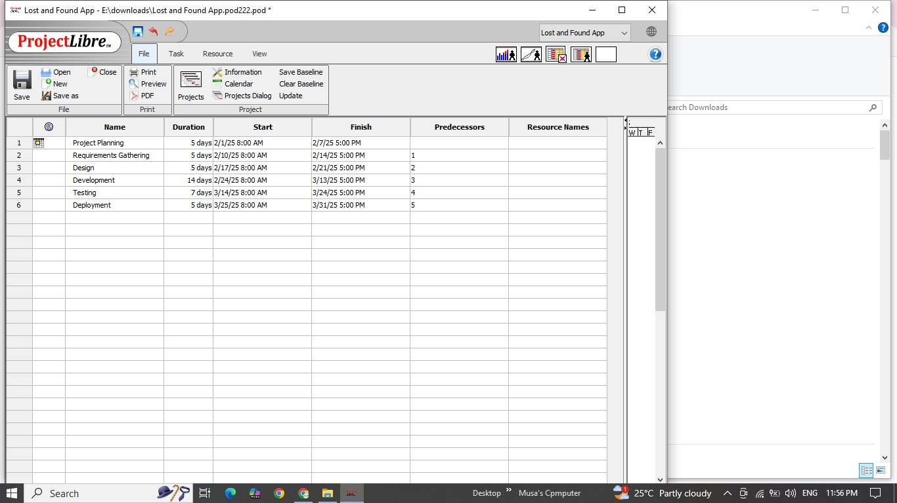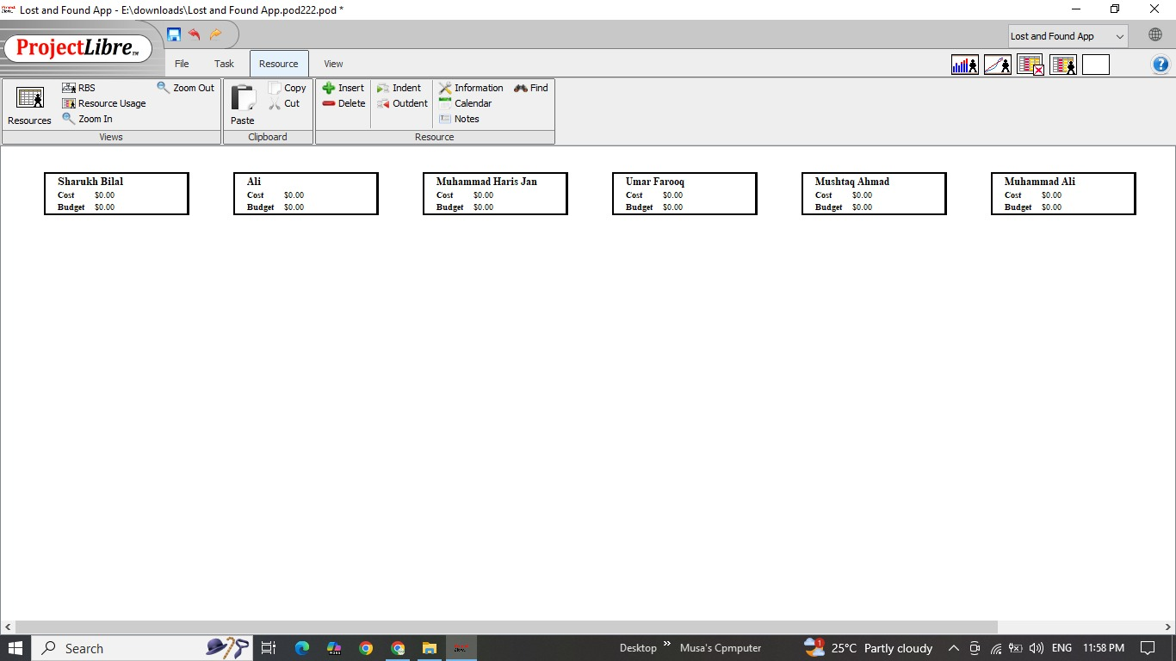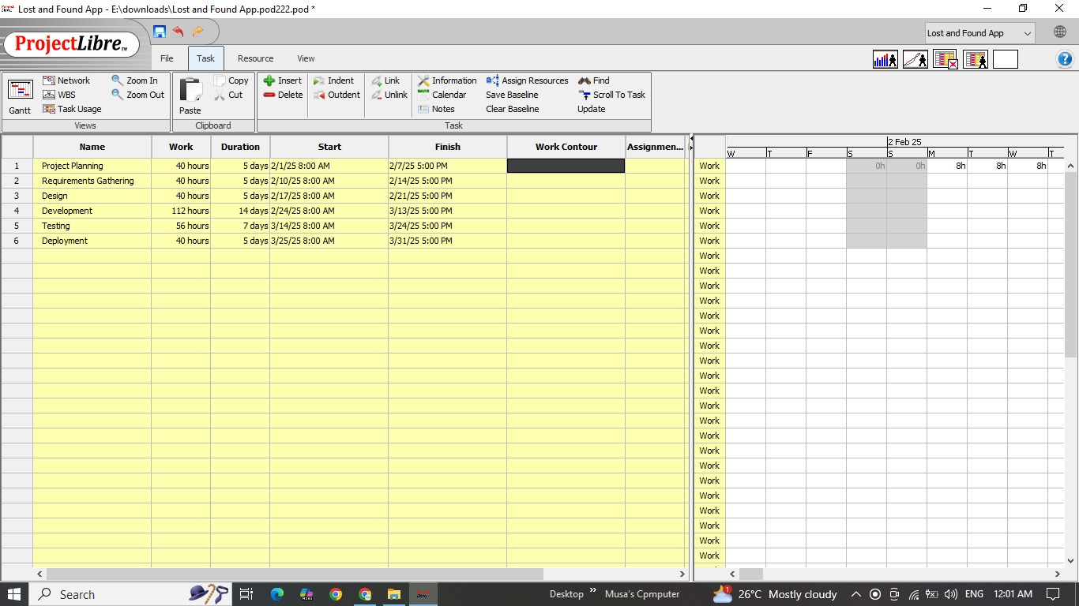

Refrences:

W3Schools (for coding help)

GitHub (for version control)

Trello / WhatsApp (for project management)

Microsoft PowerPoint (for presentation tool